General information
This operating manual describes the operational safety and the oper‐ ating characteristics of the machine.

Target group
The following persons must read and adhere to the instructions in this operating manual:
    - Persons who use the machine according to its intended purpose
    - Persons who are responsible for operational safety, operation and operating characteristics
    - Persons who operate or maintain the machine

Notes on technical documentation
The technical documentation comprises a number of documents.

Document | Identification
Operating instructions | 10354698 89409041-000400
Spare parts list | 89409041–000400
Electrical circuit diagram | 89409041–000400
Purchased parts documentation | 89409041–000400
Accompanying machine folder | 89409041–000400
Specific data and KHS standards | 89409041
Remote access operating instructions | 89409041

The technical documentation is part of the machine. The information in the Identification column is used to assign the documents to the machine.
The documents may be provided separately or compiled as a print- out or in electronic form.
The following rules apply to technical documentation:
    - Replace old versions with new versions.
    - Include all supplements.
    - Keep in the immediate vicinity of the machine for future use.
    - Pass documentation on to the new owner.

Machine assignment
The data on the nameplate clearly identifies the machine.

Name plate
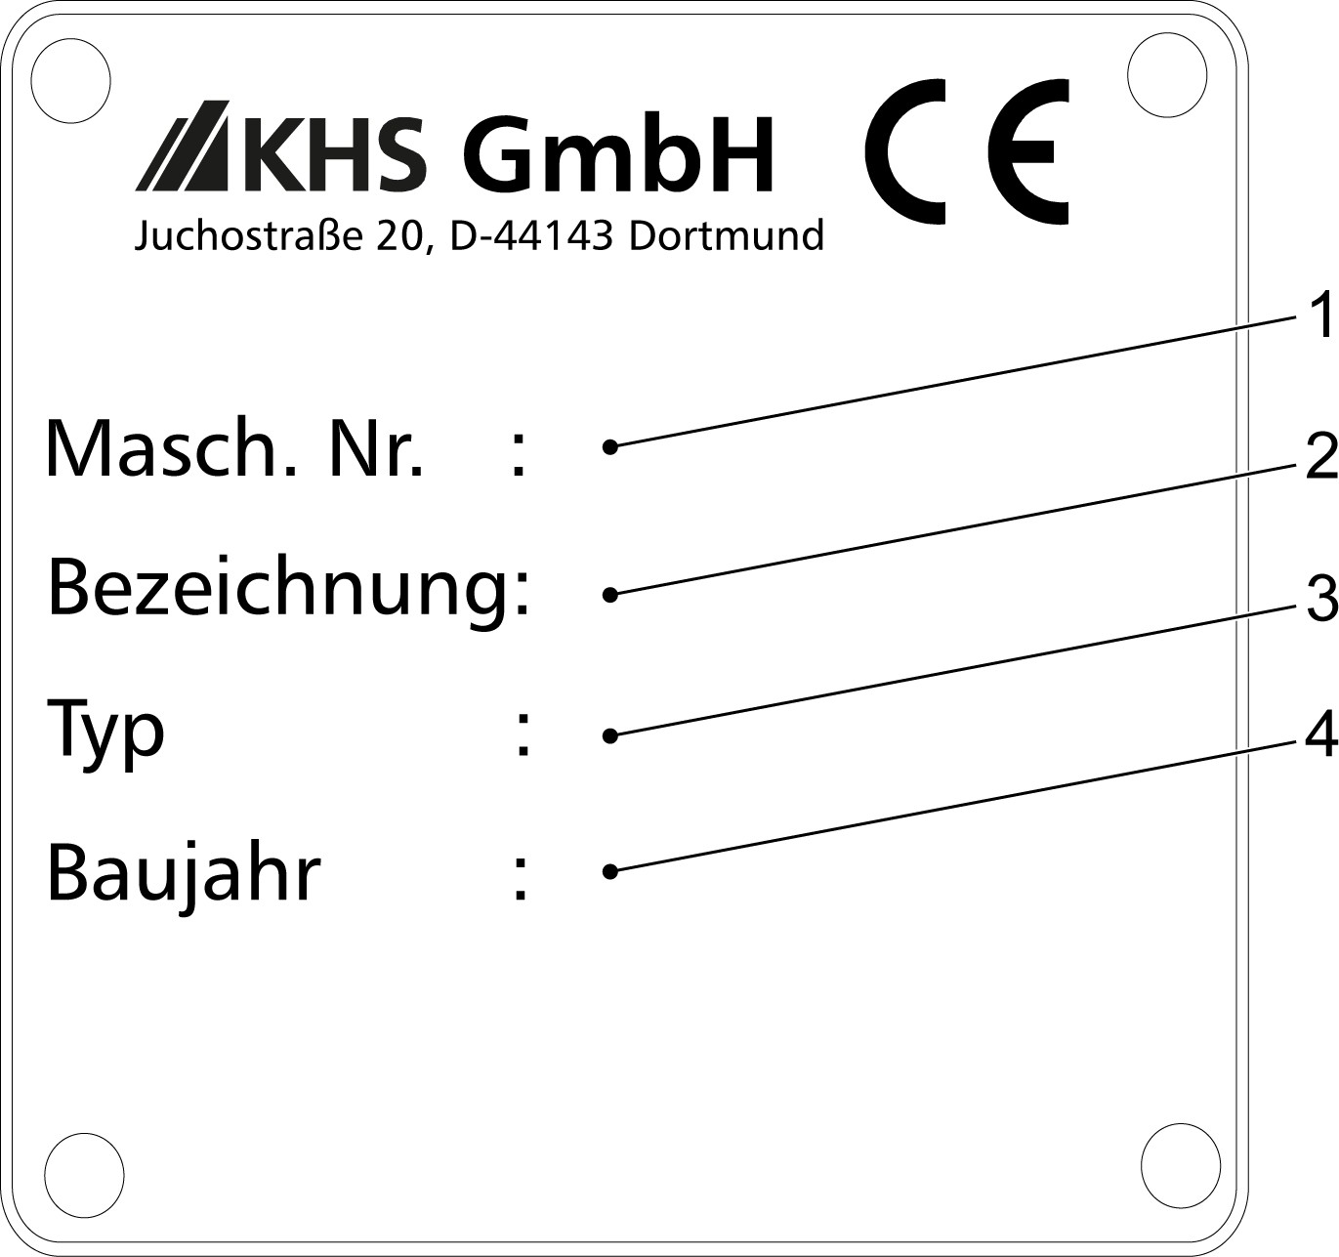
Figure 1: Name plate

1 | Machine no: | 10354698 89409041-000400
2 | Description: | Sammelpackmaschine
3 | Model: | NMP-H
4 | Year of manufac‐ ture: | 2024

The machine's identification plate is located on the machine frame on the operator side, in the "Alignment" process module.

Integrated components
Other components are integrated in the machine. These components may have been produced by KHS or by other manufacturers. The instructions provided in the technical documentation for these compo‐ nents must also be followed. Refer to the information in the "Identifi‐ cation" column to determine which documents relate to the machine.

Component | Manufacturer | Identification
Innoline GTR con‐ | KHS GmbH | 10354763
tinuous conveyor system (series II) |  | 89409041-000700

Customer service
See back of the cover sheet for contact information.

Copyright
Without the express written consent of KHS, no part of this document may be:
    - Copied
    - Photographically transmitted
    - Reproduced
    - Translated
    - Stored on another electronic medium or converted to machine- readable format

Notes on reading the manual Format of references and names
Appearance | Meaning
‘Italics in quotes’ | References to chapters in this manual
‘Italics in quotes’ | References to external documents
‘Italics in quotes’ | Quotations from the user interface
‘File ➔ Save’ | Menu command sequences
[Text or characters in square brackets] | Naming of buttons, switches and switch positions

Format of handling instructions

- Numbered step within handling instructions in a specified order.
- …

Step within handling instructions with no specified order.
  - Results of the handling step.

Format of bulleted lists
- A bulleted list item with no specified order.
- …

Format of notes



CAUTION!
This format indicates notes on safety, warning against personal hazards.
NOTICE!
This format indicates notes on safety, warning against property-related hazards.
This format indicates tips and recommendations.
ENVIRONMENT!
This format indicates notes on protecting the environ‐ ment and energy-efficient operation.

